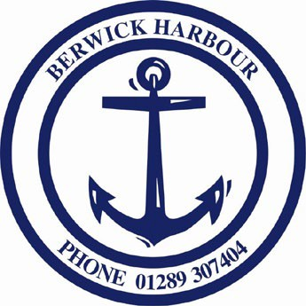
Berwick Harbour Commission

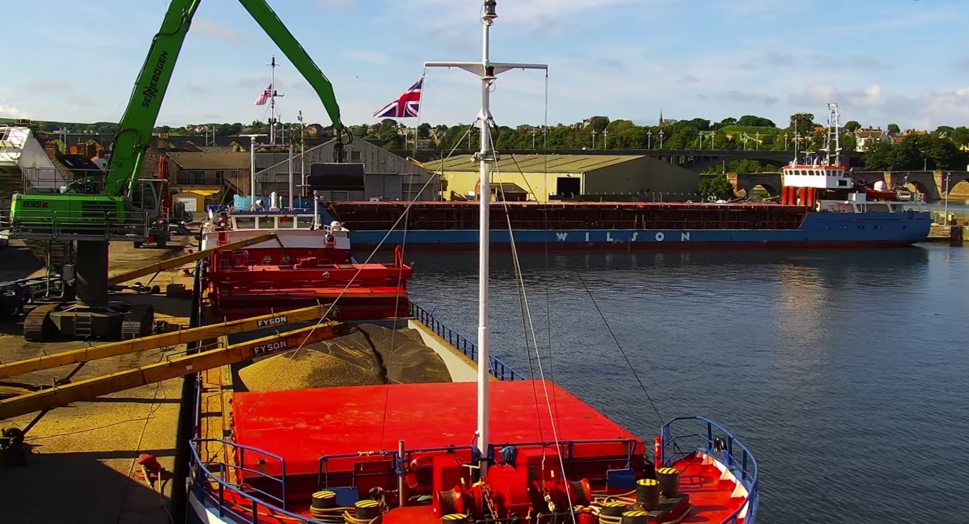

Ports & Marine Facilities Safety Code

Marine Safety Plan

Rev 4 - June 2026

This Marine Safety Plan (Rev 4 - 2026) supersedes the 2023 Edition.

Table of Contents
Part 1 – Policy, Powers and Marine Management
- Powers of the Harbour Master
- Berwick Harbour Commissioners
- Published policies and plans
- Berwick Harbour Commissioners Powers
- Environmental Duty
- Good Practice
- Consultation
- Resources
- Safety Policy
- Agents and Joint Arrangements

Part 2 – Marine Safety and Risk Management
- The Duty Holder
- Chair of the Board
- The Designated Person
- Harbourmaster
- Berwick Harbour Commissioners Officers
- Competence Standards
- Health and Safety at Work
- Safety Management Systems
- Safety Assessment and Risk Management
- Risk Assessment
- Continuous Assessment and Review

- The ‘ALARP’ Principle (As Low as Reasonably Practicable)
- Risk Control
- Auditing and Reviewing Performance
- Measuring Performance
- Link to Safety Management System
- Conservancy
- Hydrography
- Local Lighthouse Authority Duties
- Anchorages
- Admiralty Charts

Part 3 – Pilotage and the Safety of Navigation
- Pilotage
- Pilotage Directions
- Exempted Vessels
- Limits of Jurisdiction
- Authorisation of Pilots
- Contracts with Authorised Pilots
- Training
- Allocating Pilots
- Two Pilots
- Pilot Launches and Workboats
- Boarding and Landing Procedures
- Pilot and the Port State
- Pilotage Exemption Certificates (PECs)
- Use of Certificates
- Pilotage Charges
- Directions and Passage Plans
- Publication of Port Passage Guidance

- Passage Record Keeping
- Moorings
- Vessel Traffic Services
- Prevailing Conditions
- Enforcement

Part 4 – Marine and Emergency Planning
- Collision Regulations
- Dangerous Vessels
- Waiving Directions
- Emergency Planning
- Prevention of Pollution
- Port Waste Plans
- Works in Harbour (consent)
- Wrecks
- Port Security / ISPS Code

Part 5 – Management Targets

Marine Safety Plan

Document History:
Issue level | Page No’s | Date | Brief details of amendment(s) to safe operating procedure
1 | All | 2015 | First Issue
Rev 2 |  | 2020 | First Revised MSP
Rev 3 |  | 2023 | Second Revision MSP
Rev 4 |  | 2026 | Third Revision MSP

Part 1 – Policy, Powers, and Marine Management
- Powers of the Harbour Master
In considering the role of the Harbour Master, the Harbours, Docks, and Piers Clauses Act 1847 states:
“The Expression “The Harbour-Master” shall mean, with reference to any such Harbour, the Harbour-Master and with reference to any such Dock, the Dock-Master and with reference to any such Pier, the Pier-Master, respectively appointed by virtue of this or the Special Act, and with respect to all Acts authorised or required to be done by such Harbour-Master, Dock-Master or Pier-Master, shall include the Assistants or every such Harbour-Master, Dock-Master or Pier-Master.”
- Section 52 of the Harbours, Docks and Piers Clauses Act 1847 details the Harbour Master’s statutory powers, namely:
“The Harbour Master may give direction for all or any of the following purposes: (that is to say)
For regulating the time at which and the manner in which any vessel shall enter into, or go out of, or lie in or at the Harbour, Dock, or Pier, and within the prescribed limits, if any, and its position, mooring or unmooring, placing, and removing whilst therein.
For regulating the position in which any vessel shall take in or land its passengers or shall take in or deliver ballast within or on the Harbour, Dock, or Pier.

For regulating the manner in which any vessel entering the Harbour or Dock or coming to the Pier shall be dismantled, as well as for the safety of such vessel as for preventing injury to other vessels and to the Harbour, Dock or Pier, and the moorings thereof.
For removing unserviceable vessels, and other obstructions from the Harbour, Dock, or Pier, and keeping the same clear.
For regulating the quantity of ballast or dead weight in the hold which each vessel in or at the Harbour, Dock or Pier shall have during the delivery of her cargo, or after having discharged the same.
Provided always, that nothing in this or the Special Act contained shall authorise the Harbour Master to do or cause to be done any Act in any way repugnant to or inconsistent with any law relating to the Customs, or any regulations of the commissioners of Her Majesty’s Customs.”

- With specific reference to the statutory powers outlined above, the following organisation chart illustrates the lines of responsibility between Berwick Harbour Commissioners, the Chief Executive, the Harbourmaster, and employees of Berwick Harbour Commission. The chart defines governance and operational reporting relationships to ensure clarity of authority, accountability, and effective discharge of marine safety responsibilities.

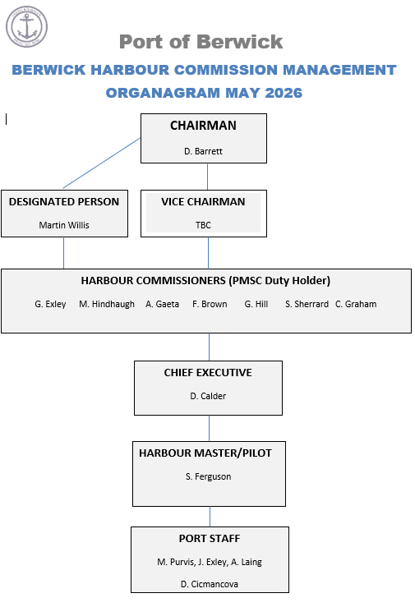

Berwick Harbour Commissioners

  - The principal functions of Berwick Harbour Commissioners may generally be classified as follows:

a) The provision, operation, and maintenance of harbour facilities, including quays, wharves, piers, and associated infrastructure.

b) Marine and navigational safety functions, including the provision of aids to navigation (such as lighting and buoyage), the removal of wrecks and other obstructions, and the maintenance dredging of navigational channels.

c) The regulation of activities within the harbour, including the movement and berthing of vessels, through the use of directions, byelaws, and licensing powers for dredging and the construction of works undertaken by third parties.

d) The conduct of harbour operations, including cargo handling and associated operational activities.

e) The provision of pilotage services, in accordance with the general duties set out in Section 2 of the Pilotage Act 1987.

f) The prevention of pollution and the protection of the marine environment, including nature conservation considerations where applicable.

Published policies and plans.

  - Berwick Harbour Commissioners, as Duty Holder, have developed their marine safety policies and plans in accordance with the standards set out in the Ports & Marine Facilities Safety Code. This document sets out the policies adopted to achieve and maintain the required standards of the Code.

  - The policies and plans are based on a comprehensive assessment of the hazards associated with harbour operations and the risks to the safety of the harbour, its users, and the wider marine environment. They are designed to ensure that risks are appropriately identified, assessed, and managed in a systematic and proportionate manner.

  - The manner in which Berwick Harbour Commissioners’ relevant policies are implemented and observed at the harbour is set out in the Harbour’s policies, plans, and associated procedures. These documents define the operational arrangements and control measures necessary to ensure effective compliance with the Marine Safety Management System and the requirements of the Ports & Marine Facilities Safety Code.

  - Berwick Harbour Commissioners’ will make available reports of its formal periodic reviews, measuring performance against its plans and against the standards as set out in the Code.

  - Berwick Harbour Commissioners policies and procedures commit the authority to undertake and regulate marine operations in a way that safeguards its harbour, its users, and the environment.

Berwick Harbour Commissioners Powers

  - Berwick Harbour Commissioners will keep their statutory powers and the extent of their jurisdiction under review to ensure they remain appropriate for the effective management of the harbour and the maintenance of marine safety. Where necessary, the Commissioners will seek to promote or support changes to legislation, powers, or jurisdiction to address identified gaps or emerging safety requirements.

Environmental Duty

  - Berwick Harbour Commissioners acknowledges that it has a general duty to exercise its functions with regard to nature conservation and other related environmental considerations, in particular with regard to the requirements of the EU Habitats Directive. If considered necessary, Berwick Harbour Commissioners will seek additional powers for these purposes.

Good Practice

  - Berwick Harbour Commissioners will ensure that relevant plans are prepared, implemented, and kept under review in accordance with the principles set out in the Ports & Marine Facilities Safety Code and with reference to the accompanying Guide to Good Practice on Port Marine Operations in Ports and Facilities. The Guide will be used as a source of recognised good practice to support compliance and continual improvement of marine safety management arrangements.

Consultation

  - Berwick Harbour Commissioners will seek to consult with harbour users and relevant interested parties when considering applicable port-marine safety- related matters.

Resources
  - Berwick Harbour Commissioners will ensure that sufficient and appropriate resources are made available to enable officers to implement and operate the Harbour’s policies, plans, and systems effectively. This includes the provision of personnel, training, equipment, and financial support necessary to ensure the proper discharge of the Harbour’s statutory duties and compliance with the Ports & Marine Facilities Safety Code.

Safety Policy

  - Berwick Harbour Commissioners has statutory duties in respect of:

- The regulation of traffic and the safety of navigation within the limits of the port
- The conservancy of the port

  - In order to affect the above statutory duties, Berwick Harbour Commissioners will ensure that plans are in place to:

- Monitor the safe arrival, departure, and movement of vessels with the port.
- Protect the general public from dangers arising from marine activities within the port.

- Prevent acts or omissions that may cause personal injury to Berwick Harbour Commissioners employees or others.

Agents and Joint Arrangements

  - The Pilotage Act provides for the delegation of certain Berwick Harbour Commissioners functions or the establishment of joint arrangements with other Harbour Authorities in order to exercise given functions. Where applicable, the Berwick Harbour Commissioners will ensure that any such arrangements are formally organised in a manner that provides for associated statutory obligations.

Part 2 – Marine Safety and Risk Management

The Duty Holder

  - Berwick Harbour Commissioners, as Duty Holder, accept responsibility for ensuring that their statutory duties and powers are discharged in accordance with the standards set out in the Ports & Marine Facilities Safety Code. The Commissioners will ensure that appropriate policies, procedures, and resources are in place to enable full and effective compliance with the Code.

Chairman

  - The Chairman of the Board of Berwick Harbour Commissioners is accountable to the Harbour Authority for the operational and financial control of the authority. The Chairman will advise the Harbour Authority on all matters related to its duties and powers, with appropriate advice from the Chief Executive and Harbourmaster. The Chairman will oversee the implementation of the Harbour Authority’s policies and decisions and will have overall executive responsibility for the safety of its operations and staff.

The Designated Person

  - Berwick Harbour Commissioners, as Duty Holder, have appointed Captain Martin Willis (Port Assist) as the Designated Person to provide independent assurance that the Marine Safety Management System is functioning effectively and in compliance with the requirements of the Ports & Marine Facilities Safety Code. The Designated Person has direct access to the Duty Holder and is responsible for monitoring the effectiveness of the system and reporting any deficiencies or areas for improvement.

Harbourmaster

  - Berwick Harbour Commissioners, as Duty Holder, will exercise their statutory powers, where necessary, to appoint a Harbourmaster. The Harbourmaster is defined in Section 2 of the Harbours, Docks and Piers Clauses Act 1847 and includes, in addition to the Harbourmaster, any duly appointed assistants. The term also encompasses any person authorised by Berwick Harbour Commissioners to act in the capacity of Harbourmaster. All such appointments and authorisations will be formally documented.

Chief Executive Officer

  - Berwick Harbour Commissioners, as Duty Holder, will ensure that executive and operational responsibilities are assigned to suitably qualified and trained personnel. All delegations of authority will be clearly defined, formally documented, and communicated to ensure effective discharge of duties and accountability within the Marine Safety Management System.

Competence Standards

  - Berwick Harbour Commissioners will ensure that the competence of all persons appointed to roles with responsibility for the safety of navigation is assessed using appropriate and proportionate means. Such assessment will consider qualifications, training, experience, and ongoing performance, and will be subject to periodic review to ensure that competence is maintained and remains appropriate to the duties undertaken.

  - Wherever possible, Berwick Harbour Commissioners will encourage port users to undertake appropriate training in order to develop a shared understanding of the marine safety management system in use.

Health and Safety at Work

  - Berwick Harbour Commissioners will conduct their undertakings in such a way as to ensure, so far as reasonably practicable, that persons not in their employment who may be affected by the undertakings are not exposed to risks to their health and safety.

Safety Management Systems

  - Berwick Harbour Commissioners’ policies are fully supported by procedures to:

    - Monitor the safe arrival, departure, and movements of vessels within Berwick Harbour Commissioners port.

    - Protect the general public from dangers arising from marine activities within Berwick Harbour Commissioners port.

    - Carry out Berwick Harbour Commissioners’ functions with special regard to their possible environmental impact.

    - Prevent acts or omissions that may cause personal injury to Berwick Harbour Commissioners employees or others or damage the environment.

Safety Assessment and Management
  - Berwick Harbour Commissioners’ approach to safety assessment and management is aimed at enhancing marine safety within their jurisdiction , including protection of life, health, the marine environment, and property.

Risk Assessment
  - Berwick Harbour Commissioners, as Duty Holder, have undertaken a formal and documented marine risk assessment of the harbour and have established systems to ensure that the findings are subject to continuous review. These systems provide for the ongoing identification of hazards, and the assessment and control of risks, to ensure that risk control measures remain appropriate, effective, and proportionate to current operations.

Continuous Dynamic Assessment and Review
  - Berwick Harbour Commissioners recognise that port marine safety assessment is a continuous, real-time process involving the identification of hazards and the management of risks as they emerge within dynamic and potentially unpredictable environments. This approach ensures that new hazards and evolving risks are identified promptly and addressed appropriately. In addition to this ongoing monitoring, the Commissioners will undertake formal reviews at suitable intervals to support, validate, and strengthen the overall risk management process.

The ‘ALARP’ Principle (As Low as Reasonably Practicable)

  - Berwick Harbour Commissioners will, as far as is practicable, take measures to eliminate any risks identified, through the assessment and review process.

Risk Control

  - All final decisions concerning risk control methods, including outcomes from regular Safety Meetings and Toolbox Talks, will consider relevant legislation, minimum standards, and human factors

Auditing and Reviewing Performance

  - In considering the safe operation and management of its port, Berwick Harbour Commissioners will monitor and review their performance against a number of predetermined indicators. The results of such reviews will be recorded and, where appropriate, information will be made available to users and other interests.

Measuring Performance

  - Berwick Harbour Commissioners will monitor its performance in relation to port marine safety.

Link to Safety Management System

  - Berwick Harbour Commissioners will endeavour to ensure that its marine safety management systems make proper use of all available powers and, in doing so, demonstrate the connection between powers adopted and the formal risk assessments.

Conservancy

  - Berwick Harbour Commissioners will endeavour to maintain and conserve the harbour to ensure it is reasonably fit for use as a port. In doing so, they will take reasonable care to ensure that the harbour is in a condition such that vessels may safely resort to it, having regard to its statutory functions and operational requirements.

Hydrography

  - Berwick Harbour Commissioners will use appropriate means to find, mark and monitor the best navigable channel or channels in its harbour. It will promulgate, as appropriate, relevant hydrographic information associated with the port, including information relating to navigational hazards.

Local Lighthouse Authority Duties

  - Berwick Harbour Commissioners, in its role as a local lighthouse authority, will seek to maintain applicable aids to navigation in accordance with the availability criteria laid down by the General Lighthouse Authorities.

Anchorages

  - Berwick Harbour Commissioners will ensure that appropriate provision is made for designating safe anchorages in the port and, where necessary, the approaches to the port.

Admiralty Charts

  - Berwick Harbour Commissioners will seek to work closely with the Hydrographic Office to ensure that relevant information required for inclusion within the Admiralty Charts and publications is made widely available.

Part 3 – Pilotage and the Safety of Navigation

Pilotage

  - Berwick Harbour Commissioners will keep under consideration whether any and, if so, what, pilotage services need to be provided to secure the safety of ships navigating in, or in the approaches to, the port. It will also consider whether, in the interests of safety, pilotage should be compulsory for ships navigating in any part of the port or its approaches. If compulsory pilotage is deemed necessary, the Commissioners will consider to which ship this should be applied and in what circumstances. It will also consider the pilotage service to be provided for those ships. Should the use of the port change, pilotage services will be reviewed to ensure that the service provided continues to meet requirements.

  - Having considered the above, Berwick Harbour Commissioners will ensure that the appropriate level of pilotage service is provided.

Pilotage Directions

  - Where Berwick Harbour Commissioners considers, in the interests of safety, that pilotage should be compulsory in the port or any part thereof, it will issue pilotage directions.

  - Berwick Harbour Commissioners will ensure that its pilotage directions define the circumstances in which pilotage is to be compulsory, how, and to which vessels they apply, and in what circumstances.

  - In providing a pilotage service, Berwick Harbour Commissioners will consider the possibility that the Master of a vessel may ask for a pilot even when not required to take on by Pilotage Directions. Berwick Harbour Commissioners will seek to make allowances for such requests and refer to them when reviewing whether in any circumstance pilotage should become compulsory.

Exempted Vessels

  - Berwick Harbour Commissioners will ensure that the risks associated with vessels to which the requirements of pilotage directions may not apply are adequately managed.

Limits of Jurisdiction

  - In the event that Berwick Harbour Commissioners consider that pilotage should be compulsory for ships navigating in any area outside its port, it will, if appropriate, apply for a harbour revision order to be made to extend its limits for the purposes of pilotage to include that area.

Authorisation of Pilots

  - Berwick Harbour Commissioners will determine the qualifications for the authorisation of its pilots in respect of age, physical fitness, time of service, local knowledge, skill, character and otherwise. Berwick Harbour
Commissioners will ensure that proper arrangements are in place for the ongoing review of pilot competence and fitness and that details of these arrangements are made available to applicants.

35.2 Berwick Harbour Commissioners is committed to exercising its clear role in the authorisation and discipline of pilots, and on the issuing of exemption certificates.

Contracts with Authorised Pilots

  - Berwick Harbour Commissioners will ensure that suitably detailed contractual arrangements are in place either directly with its authorised pilots or through a contract of service, as appropriate.

Training

  - Berwick Harbour Commissioners will ensure that their authorised pilots are trained so as to be qualified to conduct the vessels to which they are likely to be allocated. The training standards will be appropriate to the competence standards developed in parallel with the Ports & Marine Facilities Safety Code.

  - Berwick Harbour Commissioners will endeavour to satisfy themselves that prospective pilotage exemption certificate (PEC) holders are appropriately trained in the conduct of the vessel or vessels to which the certificate they are seeking applies.

Allocating Pilots

  - Berwick Harbour Commissioners will ensure, where applicable, that arrangements are in place for pilots to be allocated to vessels with sufficient time and information available to prepare a pilot passage plan.

Two Pilots

  - Berwick Harbour Commissioners will determine, through a process of formal risk assessment, any circumstances in which more than one pilot would be needed to conduct the navigation of a vessel safely.

Pilot Launches and Workboats

  - Berwick Harbour Commissioners will ensure that only those vessels that are specifically approved for the purpose will be used as pilot launches. Berwick Harbour Commissioners will also ensure that workboats used in the port, where applicable, comply with the Merchant Shipping (Workboat Code Edition 3) Safety of Small Workboat and Pilot Boat Code of Practice.

Boarding and Landing Procedures

  - Berwick Harbour Commissioners will, with reference to the geographical limit of the appropriate pilotage directions, identify safe pilot boarding and disembarkation areas.

Pilot and the Port State

  - Berwick Harbour Commissioners will ensure that the Maritime and Coastguard Agency is informed whenever reports are received from a pilot working in the port that a vessel has deficiencies which may prejudice the safe navigation of that vessel, or which may pose a threat of harm to the environment.

Pilotage Exemption Certificates (PECs)

  - Berwick Harbour Commissioners, through risk assessment, have determined that Pilotage is compulsory.

Pilotage Charges

  - Berwick Harbour Commissioners will ensure that pilotage charges for the port are published in such a manner so as to bring them to the notice of those persons likely to be interested.

Directions and Passage Plans

  - Berwick Harbour Commissioners will promote and support the use of appropriately detailed passage plans within the port. Such passage planning will be proportionate to vessel type and operational risk and will form part of the overall arrangements for the safe navigation and management of vessel movements within harbour limits.

Publication of Port Passage Guidance

  - Berwick Harbour Commissioners will provide up-to-date passage guidance applicable to the port in a suitable and accessible format. Such guidance will be kept under review and updated as necessary to reflect changes in navigational risks, harbour conditions, and operational requirements, in support of the safe navigation of vessels within the harbour.

Passage Record Keeping

  - Berwick Harbour Commissioners will ensure that suitable arrangements are in place to assist in securing access to vessel passage plans in the event that they may be needed for incident investigation purposes.

Prevailing Conditions

  - Berwick Harbour Commissioners will ensure, as far as practicable, that information is made available regarding prevailing and forecast meteorological conditions and, where necessary, their effect on the operation of the port.

Enforcement

  - Berwick Harbour Commissioners will monitor compliance with their harbour byelaws and directions and will take appropriate enforcement action where necessary. Where breaches are identified, the Commissioners may take such action as is deemed appropriate in the circumstances, which may include formal warning, reporting to the relevant authorities, or prosecution in accordance with applicable legislation.

Part 4 – Marine and Emergency Planning

Collision Regulations

  - Berwick Harbour Commissioners will keep their harbour byelaws under review and, where necessary, ensure they provide for local operational requirements and circumstances not fully addressed by the International Regulations for Preventing Collisions at Sea (COLREGs). Any such provisions will be consistent with applicable national and international maritime law and will support the safe and efficient use of the harbour.

Dangerous Vessels

  - Berwick Harbour Commissioners will ensure that due notice is provided to the directions that may need to be given in relation to a dangerous vessel that may wish to enter the port.

Waiving Directions

  - Berwick Harbour Commissioners acknowledges the need for directions to be carefully drafted to ensure that special circumstances in which they would apply are properly covered.

Emergency Planning

  - Berwick Harbour Commissioners will ensure that appropriately detailed emergency plans are published and periodically exercised in conjunction with neighbouring local authorities.

Prevention of Pollution

  - Berwick Harbour Commissioners will ensure that appropriate plans and arrangements are in place to respond to oil pollution incidents within the harbour and its approaches. Such plans will be maintained, regularly reviewed, and tested as appropriate to ensure their continued effectiveness and alignment with relevant statutory requirements and recognised good practice.

Port Waste Plans
Berwick Harbour Commissioners will ensure that a Port Waste plan remains in place in compliance to MCA requirements and shall dispose and recycle port generated waste in the most environmentally friendly way as is practicable.

Works in Harbour

  - Berwick Harbour Commissioners will ensure that its marine safety management systems have appropriate provision for works undertaken in the harbour, in particular for the regulation of dredgers and other craft associated with such works.

Wrecks

  - Berwick Harbour Commissioners will ensure that its marine safety management systems require a risk assessment to be undertaken of any wreck in, or in the approaches to the port which may cause a danger to navigation.

Port Security / ISPS Code

Berwick Harbour Commissioners comply with the requirements of the International Ship and Port Facility Security (ISPS) Code and applicable counter-terrorism standards. The Harbourmaster is appointed as the certified Port Facility Security Officer (PFSO) and is responsible for the implementation, maintenance, and oversight of the Port Facility Security Plan. Security arrangements are kept under regular review to ensure continued compliance and effectiveness.

Part 5 - Management Targets

- Permanent Performance Targets

 | Activity | Target | Status | Responsibility
1. | Health & Safety. | Maintain an effective MSMS in accordance with the Ports & Marine Facilities Safety Code & HSE | Continuous monitoring | HM / CEO
2. | Safety of Navigation. | Maintain an effective MSMS in accordance with the Ports & Marine Facilities Safety Code.  Maintain Nav aids to UK LHA National, IALA and IMO standards. | Continuous monitoring | HM / CEO
3. | Navigational and Marine Incidents | Through reporting, investigation and analysis ensure all risk assessments, procedures and guidelines are appropriate to prevent any major navigation or pollution incident. | No Incidents or occurrences recorded.  Continuous monitoring | HM / CEO
4. | Pilotage service. | Maintain 3 trained & Authorised pilots for continuous 24/7 pilotage services. | 3 Pilots authorised | HM / CEO
5. | Conservancy and Hydrographic Service. | Maintain monitoring of dock &channel depth. Through appropriate maintenance and response ensure AToN availability meets TH targets. | Continuous monitoring | HM / CEO
6. | Liaison and Consultation with river users. | Routine engagement & meetings held with  stakeholders | Engagement through Port User group, website and social media. | HM / CEO

  - Temporary Targets

 | Activity | Target | Status | Responsibility
1. | Recharacterise spoil ground | Delivery 2028-2029 | Research | HM / CEO
2. | Update and re-issue marine safety plans | On-going throughout 2026 | Continuous | HM / CEO
3. | Maintain Pilot Vessel certification & Training | On-going | Continuous | HM / CEO
4. | Increase leisure vessel calls | Continue to make available pontoon for leisure craft | Strive for continuous improvement to attract new customers | HM / CEO
5. | Train additional Pilot Vessel coxswains | On-going throughout 2026-2029 when shipping allows. | 2 in Training | HM / CEO
6. | Hydrographic survey of navigation channel | Expected 2026-2027 | Awaiting POB hydrographic survey team | HM / CEO

