Berwick upon Tweed Sailing Directions for Pleasure Craft

See www.portofberwick.co.uk for up to date information before entry.
Berwick Harbour is formed by the lower estuary of the river Tweed, the entrance being protected to the north by a pier. The principal berthing is in the Tweed Dock at Tweedmouth. Access is over a shallow bar which has a strong tide, and which can be dangerous in strong onshore winds and seas from east and south-east. Berwick is a fine historic town. The visitor’s pontoon is fully serviced with electricity and water.
Approach
It is safest to enter from 4 hours on either side of low water depending on draft.
Only the confident and experienced mariner should make entry in strong onshore winds particularly from the east and south-east.
From the north an offing of 1/2 mile clears all dangers, noting that the rocks on which the pier is constructed extend to seaward of the pier end.
From the south the approach is clean. A good line of approach is the transit of the lighthouse and the conspicuous spire of the town hall (294°) .
Entrance
The bar is of sand and boulders and varies in both depth and shape from time to time, least depths being 1.6 metres. The sands off Sandstell Point shift constantly. The tide, particularly on the ebb and especially if there is any spate in the river, runs strongly and when it meets an onshore swell can cause a confused sea with over falls on the bar. Entry on the flood may be preferred. The sheltering effect of the pier can make passage under sail hazardous good practice is to be underway by engine prior to entry. The flood can run strongly across the entrance.
Keeping 15 meters offing parallel to the breakwater on a course of 285(T) until abeam red port hand buoy, at this point a slow turn to port until the Leading Marks are in transit 207(T) SEE WEBSITE FOR UP TO DATE INFORMATION REGARDING LEADFING LIGHTS/MARKS at times these marks can be difficult to see. See www.portofberwick.co.uk for up to date Notice to Mariners. The Marks are striped black and orange with triangular topmark (look in the direction of the white painted houses see picture). Treat this line with caution as the channel tends to shift if in any doubt at all call Harbour Master Tel: 07931710156 prior to entry. Follow the transit until abeam starboard no 1 buoy, a slow turn to starboard keeping 25 meters offing at No2 & No3 buoys . You will now be mid channel between No3 & Carr rock jetty, at this point head for Tweed Dock again keep 25 meters offing the yellow buoy and when abeam adjust your course to head up the Jetty staying no more than 3 meters off. Beware of the sand bank east and somewhat south of the cardinal mark hence stay close to jetty.

Pontoon Mooring & Harbour Facilities
The visitor’s pontoon is immediately to port as one enters Tweed dock next to the harbour office. Inside, depending on dredging, there is more water with a very soft mud bottom.
Electric 16 & 32 amp connections and fresh water, it is illuminated at night and is secured by an electric security gate (code will be given by Harbour Master on arrival)
Showers and toilets are within the harbour facility.
Harbour Master (daytime): VHF Ch. 12. Tel: 01289 307404 / Mob: 07931710156 / Email: scott.ferguson@bhcshipping.com Website: www.portofberwick.co.uk
Exit /Leaving
Once clear of the Jetty steer on the Spittal church steeple then follow the green buoys to the transit. There is a red rescue buoy midway along the north running pier which makes a useful point to steer upon. On approach to the breakwater make a slow steady turn to starboard passing mid channel between red port hand buoy and the breakwater, stay parallel on a course of 105 (T) until 5 cables clear of the light house.
Facilities
There is the full range of services expected in a town of this size and Berwick is situated on both the main east coast railway line and the A1.
General
Berwick is one of the historic gems of Britain. Long a border fortress, and changing hands frequently between England and Scotland, it has a unique Elizabethan town wall, with massive ramparts and bastions. Within the walls are a wealth of fine buildings and streets, set in a grand situation of different levels, and well complemented by the three Tweed Bridges. Of particular note are the Ravensdowne Barracks, the Commonwealth Parish Church and the l8th Century Town Hall.
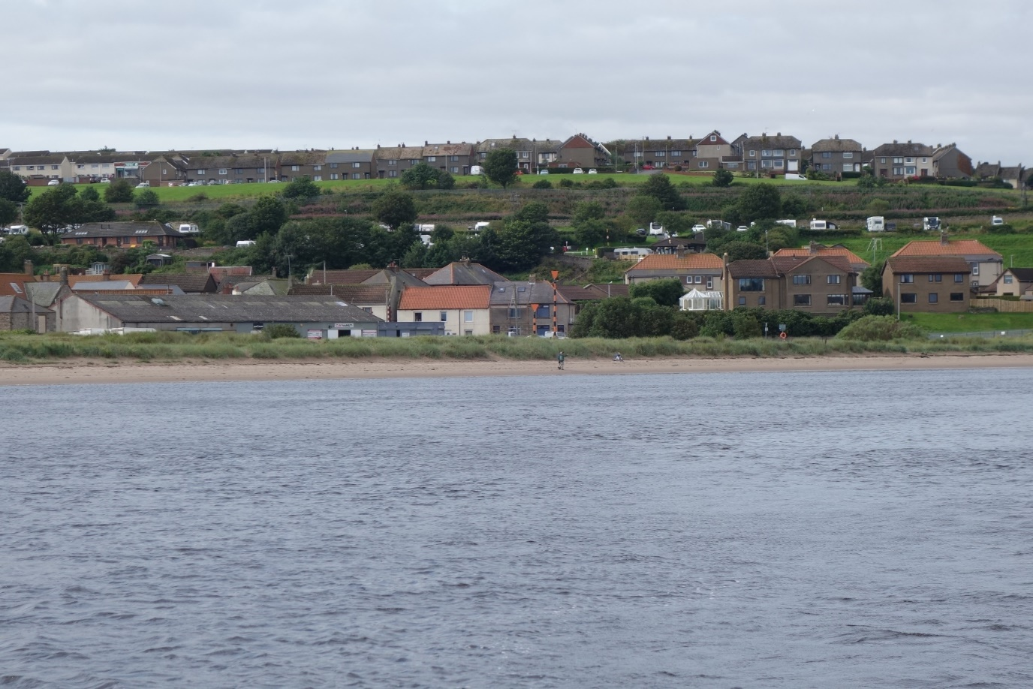

See Port of Berwick website for up to date local notice to mariners. www.portofberwick.co.uk

S. Ferguson (Harbour Master)
Jan 2026

